Reasons Why A Shadow Lake Village Homeowner

Should NOT PAY for New Gas Energy

Overview
- Save Your Health
- Save the Planet
- Save Money
- Support New Jersey’s Climate Change Leadership Policies
- Appendix: More Natural Gas Isn’t A “Middle Ground” — It’s A Climate Disaster

1. Save Your Health
Of special concern for senior communities like Shadow Lake Village homeowners is that gas stoves emit a notoriously hazardous indoor air pollutant, nitrogen dioxide (NO2), that induces asthma and other respiratory ailments. People with asthma, as well as the elderly and children, are generally at greater risk for the health effects of NO2. Being composed of nitrogen and oxygen, NO2 is one of a group of related gases called nitrogen oxides, or NOx. NOx forms when fossil fuels such as coal, oil, gas or diesel are burned at high temperatures. While all of these gases are harmful to human health and the environment, NO2 is of greater concern.
Breathing air with NO2 can irritate airways in the human respiratory system. Such exposures over short periods can aggravate respiratory diseases, particularly asthma, leading to respiratory symptoms (such as coughing, wheezing or difficulty breathing), hospital admissions and visits to emergency rooms. More importantly, longer exposures to elevated concentrations of NO2 may contribute to the development of asthma and potentially increase susceptibility to respiratory infections.
In fact, NO2 is likely to be a cause of asthma in children, and a large new study found evidence that people with lung cancer faced greater risk from NO2, ozone, and other air pollutants. The 2016 study tracked the air pollution levels from 1988 to 2011 experienced by more than 350,000 cancer patients in California. The researchers found that exposure to these air pollutants shortened their survival. This is likely because NO2, along with other NOx gases, reacts with chemicals in the air to form both particulate matter and ozone. Both of these are also harmful when inhaled due to effects on the respiratory system.
Moreover, gas leaks from residential appliances can also cause fatal asphyxiation. Even absent leaks, a 2013 Lawrence Berkeley National Laboratory study estimated that in a typical winter week, when windows are closed, millions live in homes whose gas stoves emit enough pollutants to lift indoor pollution levels beyond Environmental Protection Agency standards for the outdoors. Indoor pollution is worse in small kitchens where cramped quarters concentrate pollutants. Even when the pollutants are vented to the outdoors by an exhaust fan, they add to the Earth’s ozone, another threat to respiratory health.
Being highly combustible, gas is also a frequent culprit in home fires and explosions. In the past 20 years, explosions along New Jersey's network of gas pipelines have killed five people, injured 34 and caused more than $48 million in property damage. As the New Jersey’s gas network ages, the number of explosions resulting in death or injury is increasing.
Gas is transported over long distances by transmission pipelines, while distribution pipelines deliver gas locally to homes and businesses. But gas is also highly flammable, making the process of transporting it from wellhead to homes and businesses dangerous. Between 2008 and 2015, there were 5,065 significant safety incidents related to gas pipeline transmission and distribution, leading to 108 fatalities and 531 injuries.
In the last five years New Jersey hasn't had a fatal pipeline explosion, however in 2014 a leak caused by workers digging at a housing development led to an explosion that killed a Ewing woman, injure seven utility workers and completely destroyed 11 homes. That incident led to $1.6 million in fines against contractors and Public Service Electric & Gas, by far the largest penalty against a utility in recent history.
Two decades earlier, in the State's most destructive modern pipeline inferno, 14 apartment buildings were leveled in Edison, NJ, leaving 100 people homeless and one person left dead of a heart attack. That blast was blamed on damage from a backhoe.
Pipeline safety advocates say it's mostly good fortune that has spared New Jersey more serious or frequent incidents, noting that the age and condition of the more than 70,000 miles of pipelines crisscrossing the state leaves communities vulnerable. Pipelines are at their highest risk of major incidents: (a) within their first five years after installation, and (b) after they're several decades old — descriptions that apply to a large share of the State's network.
Amazingly, NJ's gas pipes spring 10,000 leaks a year, and they get more dangerous with age. Lynda Farrell, who heads the Pipeline Safety Coalition, said New Jersey's regulations governing certification of gas pipelines are among the least stringent in the country. “Nationally we’re in pretty damn bad shape, not only when it comes to the consistency of regulations but also in having the needed powers to regulate,” she said. “The reason for the absence of that regulation is simply that the industry has always written the safety regulations.”
There many other ways in which even new gas pipelines close to Shadow Lake Village homes would pose risks. For example, in September a series of gas explosions that rocked suburban Boston communities put the issue of pipeline safety back in the headlines. One person was killed and 25 were injured when fires and explosions ripped through dozens of homes, the disastrous result of over-pressurized pipelines. As other examples in California show: (a) in 2010, an underground gas pipe explosion in San Bruno killed eight people and destroyed more than 100 homes, and (b) in 2015 and (c) 2016, Aliso Canyon gas storage leaks forced the evacuation of more than 8,300 households in Granada Hills for more than 100 days.
See: https://www.lung.org/our-initiatives/healthy-air/outdoor/air-pollution/nitrogen-dioxide.html, https://www.epa.gov/no2-pollution/basic-information-about-no2#Effects, https://www.northjersey.com/story/news/new-jersey/2018/11/01/nj-gas-leak-explosions-old-natural-gas-pipes/1716546002/, https://www.ucsusa.org/resources/hidden-costs-fossil-fuels, and https://www.latimes.com/opinion/story/2019-07-30/berkeley-natural-gas-ban

2. Save the Planet
On July 16, 2019, Berkeley, California, did something momentous: it became the first city in the nation to ban gas in new homes and low-rise buildings. By so doing, Berkeley signaled the beginning of the end of the natural gas era. This is an altogether good thing.
Why was such a dramatic policy necessary? California has set a climate mandate of 100% clean, renewable energy by 2045 (New Jersey has a similar goal for 2050 – see Section 4). After much analysis, California determined it won’t reach that goal unless it eliminates gas from buildings. Burning gas emits carbon dioxide (CO2) and other pollutants, and its distribution and storage infrastructure leaks methane. In many California cities, including Berkeley, buildings are the second leading greenhouse-gas-emitting sector, after transportation. Now that regulations aimed at the 2045 mandate are in place for cars, trucks and coal-fired power, gas has to be next.
Gas’s climate emissions are not only generated when it’s burned as a fuel at power plants or in our homes. The full global warming impact of natural gas also includes methane emissions from drilling wells and pipeline transportation. Methane, the main component of gas, is a much more potent greenhouse gas than CO2. In fact, over a 20-year timescale, methane is 86 times more effective at trapping heat than is CO2! Preliminary studies and field measurements show that these so-called “fugitive” emissions range from 1% to 9% of total gas lifecycle emissions. Methane losses must be kept below 3.2% for natural gas power plants to have lower lifecycle greenhouse gas emissions than coal.
Large methane leaks from gas transmission and distribution pipelines are a significant source of methane emissions. A recent study, which mapped urban pipeline leaks in Boston, found 3,356 separate leaks under the city streets. The study noted that Boston is not unique; as described in Section 1, New Jersey has aging gas distribution infrastructures, and similar methane leaks are likely widespread. Beginning in 2015, the Southern California Gas Company's Aliso Canyon gas storage facility was the site of the largest methane leak in US history, with a total of 94,500 tons of methane was released between October 23, 2015 and February 11, 2016
As shown in the Appendix, Earth’s climate crisis intensifies when the production and consumption of gas soars. It is now clearer than ever that gas is NOT a solution to the climate crisis. While leaking methane along the entire gas supply chain has been at the center of the debate around the climate impact of gas, it is not the definitive issue. Even if methane leakage is addressed, there are many additional reasons why gas cannot form a bridge to a clean energy future. They include:
- New Gas Infrastructure Locks In Emissions: New gas infrastructure built today is designed to operate for many decades to come. Given the huge opposition to shutting down working infrastructure ahead of its expected economic lifespan, it is critical to stop building new gas infrastructure because the future use of that infrastructure is inconsistent with our need, and New Jersey’s goal to reduce carbon emissions by 2050.
- Gas Breaks the Carbon Budget: Even if global coal use were phased out overnight, already developed reserves of gas would push the world above 1.5°C of warming. There’s simply no room for more gas.
- Climate goals require the energy sector to be decarbonized by 2050: Even if methane leakage is kept to a minimum, current plans for gas production growth drastically overshoot climate-safe models and are a bridge to climate disaster.
- Gas Is Not Essential for Grid Reliability: Wind and solar require balancing, but gas is not the only, nor the best, resource available for doing so. Battery storage is fast becoming competitive with gas plants designed for this purpose (known as “peakers”). Wind and solar plants that are coupled with battery storage are also becoming a competitive “dispatchable” source of energy. Managing high levels of wind and solar on the grid requires optimizing a wide range of technologies and solutions, including battery storage, demand response, and transmission. There is no reason to favor gas as the primary solution.
- Endorsing IPCC Targets Means Phasing Out Natural Gas: supporting continued buildout of natural gas assets and infrastructure in the US is not “moderate” climate policy, nor a “middle ground.” It is an admission of failure, an acknowledgment that the US will NOT do its part to avert 2 degrees of global warming and the horrors that will follow in its wake.
Besides Berkeley, at least 50 other California cities including Los Angeles, San Francisco, Santa Monica and San Jose are poised to encourage all-electric new construction in coming months. They may not ban gas altogether in new construction, but the aim is the same — a retreat from gas.
Of course, because they economically disadvantage existing gas pipeline infrastructure, bans on gas often attract fierce opposition. However, in Berkeley’s case, City Council member Kate Harrison spearheaded a six-month-long outreach program that proved so persuasive that at the hearing before the July 16, 2019, vote, not a single person spoke against the measure, not even an official from Pacific Gas & Electric (PG&E), the nation’s fifth-largest distributor of gas. PG&E, which supplies energy to 16 million customers, was in effect acknowledging that its gas infrastructure will wind down while its electricity infrastructure expands, and in fact, spoke in favor of the ban!!!
Shadow Lake Village is comprised of 952 townhomes that were built from 1972 to 1980. These homes typically range from 909 to 1,391. Assuming two-thirds of the homes are two-bedroom, 1,391 square feet, and one-third are one-bedroom, 909 square feet, then the average home is ((1391)*2 + (909))/3 = (2782+909)/3 = 3691/3 = 1230 square feet.
Figure 1 shows that for space heating, water heating, clothes drying, and cooking for each 1230 square feet home with gas appliances the total CO2 emissions are 7,752 lbs/year and 6.1 NOx lbs/year vs for an all-electric home the total CO2 emissions are 6,839 lbs/year and 3.7 NOx lbs/year. Here, electricity for the all-electric home is generated using the "alternate fuels” described in the Federal EPA Emissions & Generation Resource Integrated Database (eGRID).
eGRID is a comprehensive source of data on the environmental characteristics of almost all electric power generated in the United States. These environmental characteristics included are: air emissions for nitrogen oxides, sulfur dioxide, carbon dioxide, methane, and nitrous oxide; emissions rates; net energy generation; resource mix; and many other attributes.
In short, Figure 1 shows that in contrast to a home using gas appliances for space heating, water heating, clothes drying, and cooking, a comparable all-electric home currently provides a 13.3% reduction in CO2 emissions, and a whopping 66.5% reduction in NO2 and NOx emissions! More importantly, as noted earlier, since both California and New Jersey have set new climate mandates of 100% clean, renewable energy by 2045 and 2050 respectively, future emissions comparisons will favor the all-electric home even more strongly.
Last but not least, NO₂ and other NO_{x} interact with water, oxygen and chemicals in the atmosphere to form acid rain. Acid rain harms sensitive ecosystems such as lakes and forests (Learn more about Acid Rain). The nitrate particles that result from NO_{x} make the air hazy and difficult to see though. This affects the many parks that we visit for the view (Learn more about Visibility and Haze). Finally, NO_{x} in the atmosphere contributes to nutrient pollution in New Jersey coastal waters (Learn more about Nutrient Pollution).
Bottom Line
There is an urgent need for policymakers, investors and even us “ordinary Shadow Lake Village citizens” to use climate goals as a starting point for energy decisions, particularly when it comes to gas. Rather than searching for ways to justify using the abundant supply that new drilling methods have unleashed, policymakers, investors and homeowners(!) should consider how much gas is incompatible with achieving the goals of the Paris Agreement. The answer is the same for gas as it is for coal and oil: We need less gas, not more.
See the Appendix to learn more in depth about why gas isn’t a “middle ground”, instead it’s a climate disaster! To better understand the gas ‘bridge fuel’ myth, download the report at: http://priceofoil.org/program-areas/stopping-carbon-lock-in/gas/
See also: https://www.latimes.com/opinion/story/2019-07-30/berkeley-natural-gas-ban, https://www.ucsusa.org/resources/hidden-costs-fossil-fuels, https://www.ucsusa.org/resources/environmental-impacts-natural-gas, https://arstechnica.com/science/2019/08/wind-power-prices-now-lower-than-the-cost-of-natural-gas/, https://www.kqed.org/science/1945656/trade-in-your-gas-stove-to-save-the-planet-berkeley-bans-natural-gas, https://blog.ucsusa.org/mark-specht/why-berkeley-banned-natural-gas-in-new-buildings, https://www.epa.gov/energy/emissions-generation-resource-integrated-database-egrid, https://www.factcheck.org/2018/09/how-potent-is-methane/, https://www.vox.com/energy-and-environment/2019/5/30/18643819/climate-change-natural-gas-middle-ground

3. Save Money
With each passing week, it’s clear that low-cost renewables can and will become our major energy sources that will permanently displace gas. Wind and solar are already cheaper to build and operate than gas in most markets. Cost is clearly not a prohibitive factor to adding renewable generation capacity, whether to replace gas energy capacity or to meet rising demand. On November 19, 2019, New Jersey Governor Phil Murphy signed an executive order increasing the state’s target for “offshore wind-generated electricity” to 3,500 megawatts (MW) by 2030, and 7,500 MW by 2035.
As Governor Murphy said in a statement, “There is no other renewable energy resource that provides us with either the electric-generation or economic-growth potential of offshore wind. When we reach our goal of 7,500 megawatts, New Jersey’s offshore wind infrastructure will generate electricity to power more than 3.2 million homes and meet 50% of our state’s electric power need.”
Natural gas—on its own, without considering the cost of a plant to burn it for electricity—is already over $20/MW-hr. That means wind sited in the central US states is already cheaper than fueling a natural gas plant, and wind sited elsewhere is roughly equal. In a recent statement, Gregory Wetstone, president and CEO of the American Council on Renewable Energy, sought to highlight the economic importance of wind energy to the U.S. “If the United States is going to compete and win in the 21st century’s global clean energy marketplace, ramping up our nation’s wind production is going to be absolutely critical. Offshore wind has an important role to play as an untapped, but potentially massive, emerging market in the U.S. that can drive billions of dollars in economic investment and create tens of thousands of American jobs.”
Based on very brief web searches, the following are the potential costs of installing new appliance(s) and their gas supply piping when converting an all-electric home to gas:
- Gas Space Heater Costs
- Hydronic (hot water) gas baseboard heaters can replace electric baseboard heaters where adding ducting for a forced-air gas system is cost-prohibitive. However, unlike electric baseboard heaters, hot water baseboard heaters will exhibit a time delay to heat up or cool down. Another disadvantage is that there's no way to add air-conditioning to the system. These systems use a water heater and a pump to circulate hot water, which is piped through enclosures styled to look like large decorative baseboards. Typical costs for a 1,400 square foot home: ~$6,000-$8,000 (see: https://home.costhelper.com/hydronic-baseboard-heater.html)
- Gas Water Heater Costs
- Tankless gas water heaters are about 23% more efficient than a traditional storage version, which is about 60% efficient. Gas tankless water heaters cost up to three times more than storage heaters: ~ $3,000 including installation by a qualified plumber. Most gas tankless water heaters qualify for a $300 federal tax rebate. Many states offer similar incentives. (See: https://www.abacusplumbing.net/2016/12/tankless-water-heaters-worth-investment/)
- Gas Clothes Dryer Costs
- Cost to install a gas dryer with venting to the outside will likely range from $800 to $1800. Actual price will depend on job size, conditions, and finish options. (See: https://porch.com/project-cost/cost-to-install-a-gas-dryer)
- Gas Stove Costs
- Gas stoves run anywhere from $350 to $3,000 or more depending on the brand, features, quality and finish. Gas line installation inside the home can cost up to $200 or more. Top-vent and direct-vent gas stoves can even exceed $6,000. These stoves have an integrated downdraft style vent, usually located in the middle or back of the stove. Some models have a vent that pops up from the back of the unit. You may pay more, but you can skip the vent hood. These styles are incredibly useful for island installations.
- If you need a stove hood vent installed, the cost is $250 to $600, depending on the complexity of the job. Hoods come in wall mount, under cabinet mount and ceiling mount for islands. Installation pricing is similar between styles and vary depending on the complexity of your homes layout.
- Installation of either Wall vs. Island Ducted Kitchen Vent Hood Systems averages $85 per hour in labor. Wall units cost anywhere from $200 to $3,000 with high end models running $6,850 and utilize either wall or ceiling ductwork while using the wall for stability. Island hoods run anywhere from $300 to $3,000. They also need to be a few inches larger than the cook surface for effectiveness.
(See: https://www.homeadvisor.com/cost/kitchens/install-an-appliance/#gas)
- Outside Gas Supply Line: Main and Lateral Line to the Home Costs
- From the NJ Natural Gas (NJNG) presentation at the Shadow Lake Village Town Hall Meeting on December 2, 2019, NJNG requires a homeowner to connect at least one qualifying appliance that's consuming gas within six months from the date of the free installation by NJNG of a gas service line to the home. See below: “3.1 Questions for NJNG”.
- Internal Gas Supply Piping from Gas Meter to Individual Appliances Costs
- Actual cost will depend on job size and conditions (see also individual gas appliance costs above)
- Minimum Monthly NJNG “Customer Charge” Costs
- From the NJ Natural Gas (NJNG) presentation at the Shadow Lake Village Town Hall Meeting on December 2, 2019, there are a variety of fees associated with a new gas account including, but not limited to, an one-time account opening charge of $15, a minimum monthly charge of $8.80, a two-month security deposit of at least $40, and of course the monthly fee based on the amount of gas used in that month.
- Not a Cost, but the Disruption Associated with Gas Piping Installation
- From a project involving half as many homes in Estero, Florida, gas piping Main Line and Lateral Line construction was expected to require at least three months.
- Future Re-Sale Penalty an All-Gas Home May Suffer
- As described in Section 2 above, since New Jersey’s new offshore wind infrastructure is expected to generate electricity to power at least 50% of our State’s electric power needs, we could easily expect that in 5-10 years an all-gas home will suffer a re-sale penalty when compared with an all-electric home. Before climate change made us aware of the need to switch to sustainable energy sources, an all-gas home in NJ may have enjoyed a 3% premium over an all-electric home(?) Thus in this new era, with roles reversed, we could easily expect a 3%, or more, resale penalty for an all-gas home.

3.1 Questions for NJNG
- Question 3.1: How many Shadow Lake Village homeowners are required to sign up to make the gas project a “GO”?
- Question 3.2: When will homeowners be required to sign up?
- Question 3.3: What costs will a homeowner be required to pay if they wait until later to sign up?
- Question 3.4: What Main Gas Line costs will an individual homeowner be responsible for, and are those costs determined by the number of homeowners who decide to connect at least one qualifying appliance that's consuming gas within six months?
- Question 3.5: What Lateral Gas Line costs will an individual homeowner be responsible for if they subsequently decide NOT to connect at least one qualifying appliance that's consuming gas within six months?
- Question 3.6: If approved, when will the gas project start, and how long will it take to install the gas distribution network?
- Question 3.7: As described in Section 2 above, since New Jersey’s new offshore wind infrastructure is expected to generate electricity to power at least 50% of our State’s electric power needs, in five years what re-sale penalty would you expect an all-gas home to suffer when compared with an all-electric home?
- Question 3.8: In ten years what re-sale penalty would you expect an all-gas home to suffer when compared with an all-electric home?
See: https://www.cnbc.com/2019/11/21/new-jersey-ramps-up-targets-looks-to-go-big-on-offshore-wind-energy.html, https://arstechnica.com/science/2019/08/wind-power-prices-now-lower-than-the-cost-of-natural-gas/, https://acore.org/staff/gregwetstone/, https://www.55places.com/new-jersey/communities/shadow-lake-village, https://www.swcaonline.com/, https://www.swcaonline.com/files/Natural%20Gas%20Presentation-FINAL%20April%202019.pdf

4. Support New Jersey’s Climate Change Leadership Policies
The popular image of gas cooking and heating — clean, cheap and reliable, a “bridge fuel” from coal to renewables — requires drastic revision. Gas is in fact the new coal; its greenhouse-gas emissions overall in the U.S. have surpassed coal’s since 2015. To counter this, New Jersey is advancing and diversifying its clean energy portfolio through leadership and strong policies. New Jersey has one of the most ambitious Renewable Portfolio Standards in the country by requiring 35% of the energy sold in the State come from qualifying energy sources by 2025 and 50% by 2030. Promoting a diverse portfolio of new clean in-state generation will lessen dependence on fossil fuels, help grow the state’s economy, reduce emissions and combat climate change.
On June 10, 2019, the State of New Jersey released the Draft 2019 Energy Master Plan (EMP), which provides an initial blueprint for the total conversion of New Jersey’s energy profile to 100% clean energy by 2050, as directed by Governor Murphy’s Executive Order 28. The EMP encompasses a dramatically broader scope than previous EMPs, and features a series of seven strategies that will guide the state to address the imminent threat of climate change and to reach Governor Murphy’s 100 percent clean energy goal. Specifically, the following NJ EMP strategy is in direct opposition to adding a new (and potentially dangerous – see Section 1 above), gas pipeline infrastructure in Shadow Lake Village:

Strategy 4: Reducing Energy Use and Emissions from the Building Sector through decarbonization and electrification, the expansion of statewide net zero carbon homes incentive programs, and the development of EV Ready and Demand Response Ready building codes.

See: https://www.nj.gov/dep/aqes/opea-clean-energy.html, and https://www.latimes.com/opinion/story/2019-07-30/berkeley-natural-gas-ban, https://www.nj.gov/emp/, and https://www.bpu.state.nj.us/bpu/pdf/publicnotice/EMP%20Press%20Release%20610.pdf

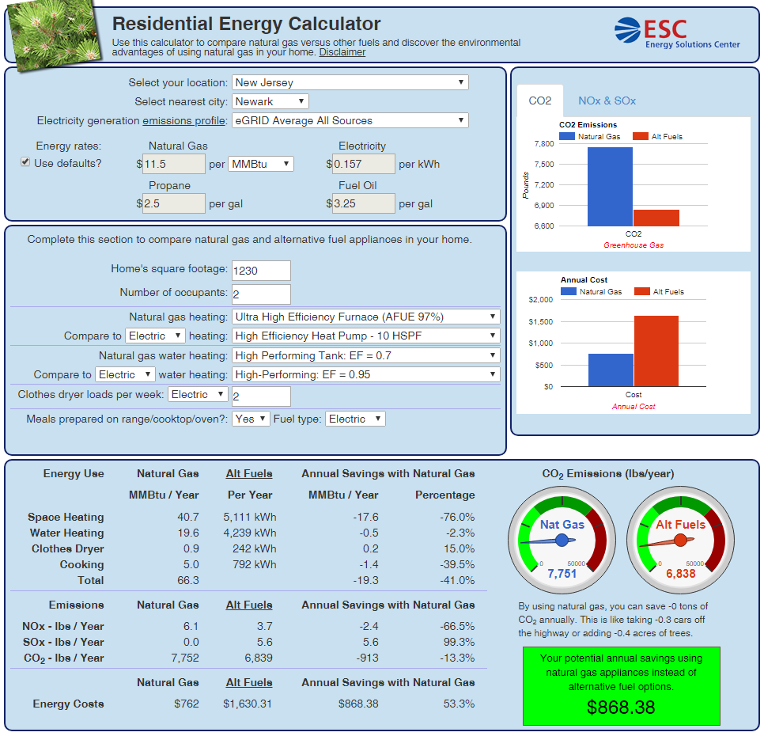
Fig. 1. Comparing CO2 Emissions and Annual Costs for Gas and Electric: Heating, Hot Water and Clothes Drying (from: http://www.energydepot.com/ResidentialEnergyCalculator/)*
* “Disclaimer: This calculator is sponsored and presented by the Energy Solutions Center. Neither ICF International, nor the Energy Solutions Center, nor any member of The Energy Solutions Center, nor any person on their behalf:
a. Makes any warranty or representation, express or implied, with respect to the accuracy, completeness, or usefulness of the information contained in this application or report, or
b. Assumes any liability with respect to the use of or for damages resulting from the use of any information disclosed in this application or report.”

5. Appendix: More Natural Gas Isn’t A “Middle Ground” — It’s A Climate Disaster
To tackle climate change, natural gas has got to go.
By David Roberts@drvoxdavid@vox.com May 30, 2019, 10:10am EDT
From: https://www.vox.com/energy-and-environment/2019/5/30/18643819/climate-change-natural-gas-middle-ground
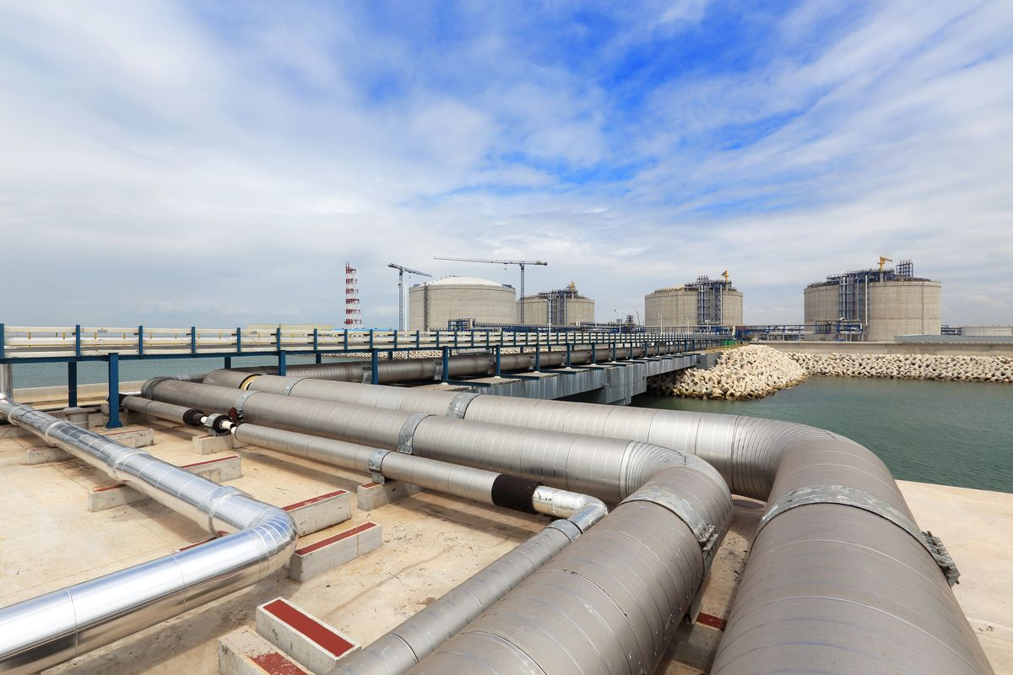A liquid natural gas (LNG) receiving terminal. Shutterstock
Expert opinion on climate change policy has been evolving quickly. The opinion of policymakers has not always kept up. One area where this split is particularly notable is around the role of natural gas in a clean energy future.
For Democrats, support for natural gas has always been a signifier of moderation on climate policy. President Obama encouraged natural gas production and proudly took credit for the emission reductions it produced when substituting for coal. It was en vogue during the Obama years to refer to natural gas as a “bridge fuel,” a fossil fuel that could help reduce emissions while truly clean alternatives were developed.
To this day, there are “centrist” Democratic groups pushing the line that embracing natural gas (and nuclear, and carbon sequestration) is the “moderate” road forward on climate change.
No one knows yet what Joe Biden meant when he promised a “middle ground” on climate strategy a few weeks ago (he’s expected to release some policy shortly). But the first thing I thought of when he said it was natural gas. Biden is likely to try to signal that he’s a centrist by embracing natural gas’s role as a bridge fuel.
It’s a beguiling strategy for Democrats who are fearful of being seen as too liberal. But I’m afraid it’s a dead end.
You see, all those arguments for natural gas that seemed so compelling during the Obama years have fallen apart. It’s now clear that if the world is to meet the climate targets it promised in Paris, natural gas, like coal, must be deliberately and rapidly phased out. There’s no time for a bridge. And clean alternatives are ready.
Since climate policy promises to be a hot item this primary season, let’s quickly review the reasons natural gas has got to go. Helpfully, the think tank Oil Change International (OCI) has just put out a paper making those very arguments. Let’s review the five topline ones for why natural gas is not, and can not be, a bridge to a cleaner energy system.
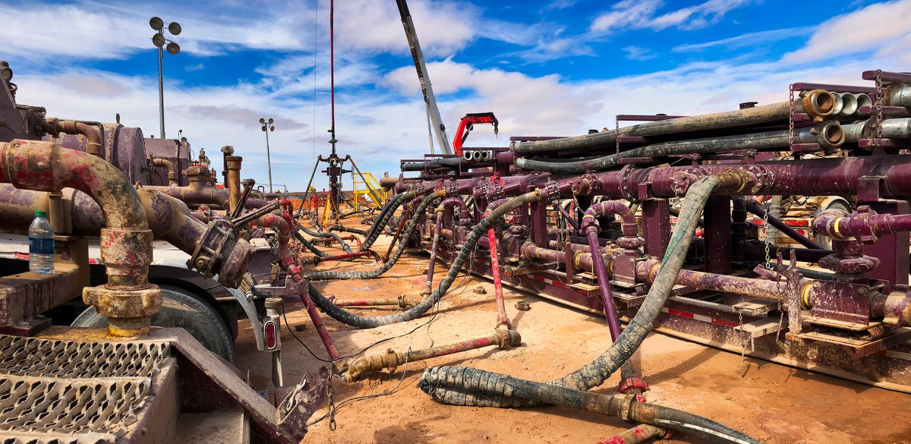Fracking well head and pumps, in Texas. Shutterstock
Methane leakage may make natural gas as bad as coal, but it’s not the reason gas has no future
The paper leads with a quick note on methane leakage in natural gas production. Methane is a fast-acting greenhouse gas with enormous short-term impacts on climate. It leaks at every stage of the natural gas production and transportation process.
While gas itself is less carbon-intensive than coal, if enough methane leaks during its production, its greenhouse gas advantages are wiped out.
Does that much methane leak? Some studies have suggested that, yes, methane leakage is bad enough to make natural gas the greenhouse equivalent of coal. Other studies have suggested that gas still has an advantage (and proponents note that leakage could be reduced).
For our purposes here, it doesn’t matter. None of the five arguments against natural gas rely on any particular estimate of leakage. All of them would apply even if natural gas achieved zero leakage (which is impossible). The same is true regarding the local environmental impacts of natural gas production (air pollution, habitat loss, earthquakes) — they are dreadful, but even if they were eliminated, the following arguments would still apply.
1) Gas breaks the carbon budget
Honestly, this one is enough to rule out gas on its own.
It’s simple: Even setting aside methane leakage, there’s too much carbon in the natural gas we’ve already discovered for us to stay within the carbon budget promised in Paris. Never mind finding more — if we burn what we’ve already found, we’ll bust the budget.
The world’s nations have agreed to hold the rise in global average temperatures to no more than 2 degrees Celsius, with efforts to hold it to 1.5. (You will recall that the Intergovernmental Panel on Climate Change report that came out last year specifically investigated the difference in impact between 1.5 and 2 degrees. Long story short: The difference is substantial and 2 degrees would be horrific.) Staying within those targets leaves humanity with a limited amount of greenhouse gases it can still release — its carbon budget.
The chart below from OCI is eye-opening. On the left is the carbon content of the “developed reserves” of fossil fuels around the world, i.e., “already-operating or under-construction fields and mines.” On the right are the carbon budgets for 1.5 and 2 degrees, respectively.
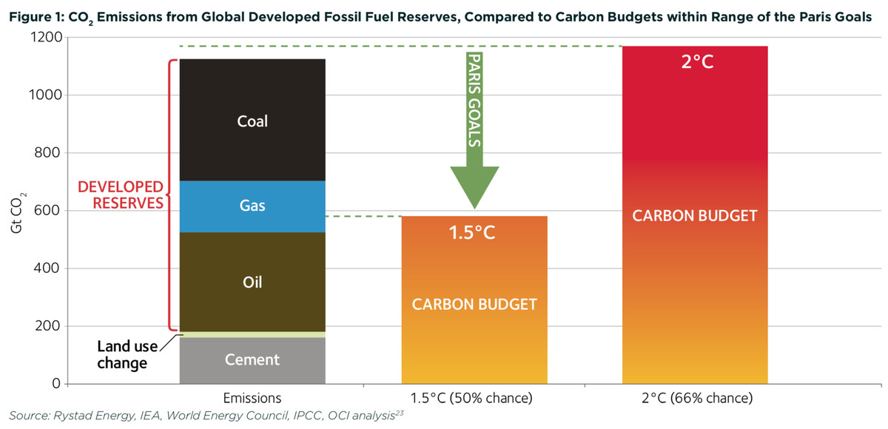OCI
If we burn the fossil fuels we are already exploiting, we will use up the 2-degree budget. Even if global coal use were eliminated overnight, burning the oil and gas we’re already digging up would blow the 1.5-degree carbon budget.
OCI emphasizes the obvious implication: “There is no room for new fossil fuel development — gas included — within the Paris Agreement goals.” If the countries of the world are serious about their shared targets, they must cease new fossil fuel exploration and cancel plans for new wells and mines.
The IPCC says the world needs to be half decarbonized by 2030, and fully decarbonized by 2050, to hit the 1.5-degree target. To give developing countries more room, wealthy developed nations like the US should ideally decarbonize faster.
To do that, the US will have to phase out all fossil fuel use as fast as it conceivably can. There’s no room for a bridge. Policymakers must begin consciously encouraging and designing energy systems that run entirely on carbon-free resources.
2) Coal-to-gas switching doesn’t cut it
Shutting down coal power plants and opening gas plants in their place will generally reduce emissions, depending on a variety of variables (again including methane emissions). Coal-to-gas switching is responsible for a big chunk of the emission reductions in the US electricity sector over the past few years.
But one thing is certain: Coal-to-gas switching doesn’t reduce emissions to zero. And zero-as-soon-as-possible is the goal.
In its New Energy Outlook for 2018, Bloomberg New Energy Finance (BNEF) ran a scenario in which global coal use was phased out by 2035 and the market was otherwise left to work. It found that gas would fill about 70 percent of the void. That is incommensurate with Paris targets.
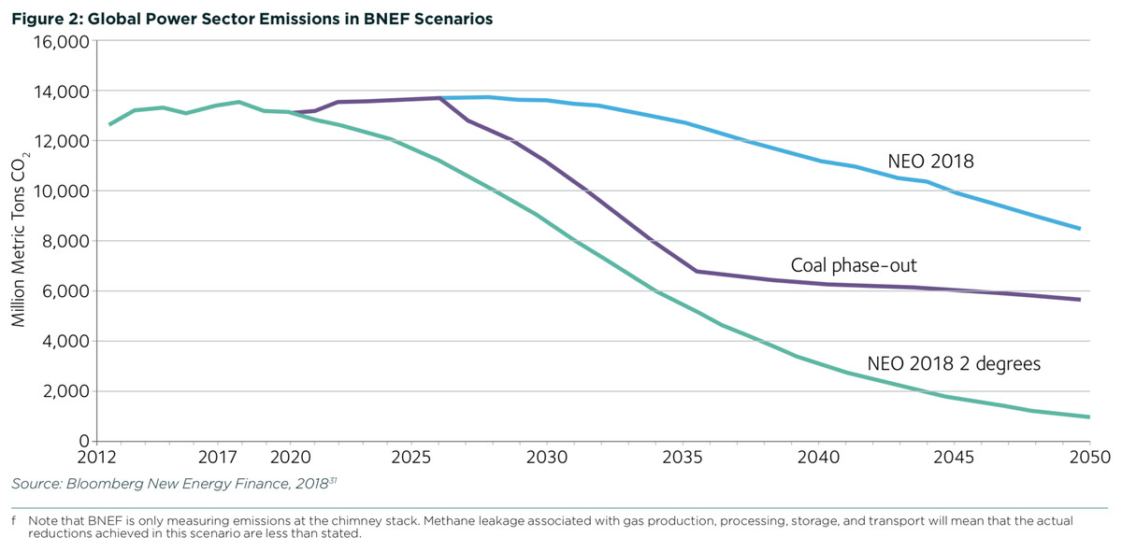OCI
Even with a global coal phaseout, we’ll blow through the 2-degree target, much less the 1.5-degree target, unless gas is phased out as well.
Fossil fuel industries respond by pointing to the potential for “negative emissions,” but all such technologies are speculative at scale and face potentially insurmountable challenges. Allowing gas infrastructure to continue being built on the hope that negative emissions will pan out is madness.
3) Bulk renewables can displace both coal and gas
In most markets, bulk renewables — utility-scale wind and solar power plants — are the cheapest form of power as measured by the “levelized cost of energy” (LCOE, which seeks to take all costs into account). This was confirmed last year by the financial advisory firm Lazard, which publishes annual LCOE estimates.
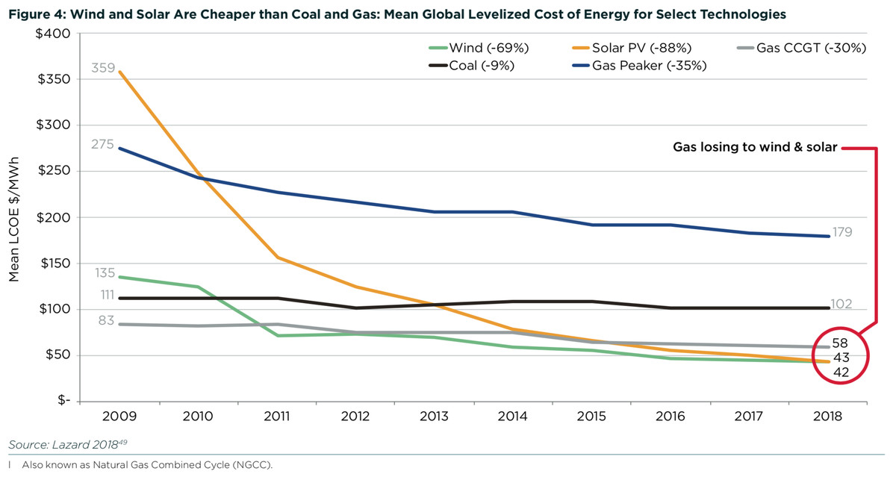OCI
BNEF also does yearly LCOE analysis and has found the same thing:
The relentless decline of solar and wind costs has made these technologies the cheapest sources of new bulk electricity in all major economies, except Japan. This includes China and India, where not long ago coal dominated capacity additions, as well as the U.S., where the shale gas revolution has made gas cheap and abundant.
Renewables are already driving down prices in wholesale markets and causing existing natural gas plants to be run at much lower utilization rates than they were designed (and financed) for. And renewables are only getting cheaper, while cheap natural gas can’t last forever.
Of course, LCOE is a limited measure. What matters for variable renewables is not their average cost but their value at particular times and locations. Wind and solar do, after all, come and go with the weather. Which brings us to ...
4) Gas isn’t needed for grid reliability
Renewable energy skeptics like to claim that natural gas power plants are required on the grid to balance out variable renewable energy, which comes and goes with the wind and sun.
OCI responds with three arguments.
First, most natural gas plants being built these days are combined cycle gas turbine (CCGT) plants, which produce the cheapest power. “In the United States alone, around 24 gigawatts (GW) of CCGT capacity was commissioned in 2017 and 2018, and more than 14 GW was under construction at the beginning of 2019,” writes OCI. “There is more than 425 GW of CCGT capacity in operation globally.”
But CCGT plants are not the plants that can ramp up and down quickly to balance renewables. They are big and relatively slow, meant to run at high utilization rates and provide bulk power. In other words, they compete with, rather than complement, renewables.
Second, the faster natural gas plants — gas reciprocating engines (GRE) and open cycle gas turbines (OCGT), or “peakers,” named for their function of spinning up during peaks of energy demand — are increasingly being beat out by batteries, which respond even quicker.
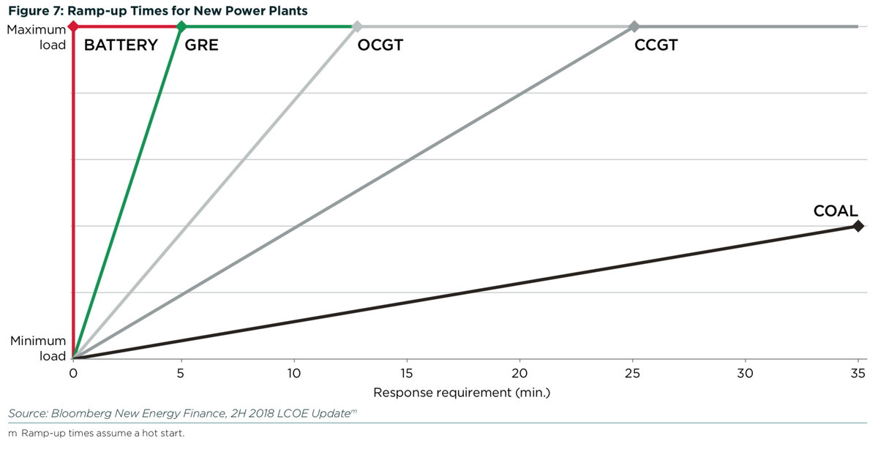OCI
Wind and solar plants coupled with battery storage — which can compete directly with peakers — are getting cheaper. OCI cites a BNEF report showing that they “are already able to compete with new coal or gas plants on an LCOE basis in Germany, the United Kingdom, China, Australia, and the United States.”
For now, most utility-scale battery storage is in the four-hour range. Those battery installations are expected to get cheaper than natural gas peakers in the early 2020s. But they still have somewhat limited application.
However, OCI notes, “a study by Wood Mackenzie in 2018 found that six- and eight-hour battery storage systems, which are beginning to enter commercial operation today, can address 74 percent and 90 percent of peaking demand, respectively.” Once batteries get more sophisticated and cheaper, there won’t be much left for natural gas peakers to do. (For a longer look at how natural gas is getting displaced, see my article here.)
Third, OCI argues that the key to stable, reliable grids is not any individual technology but the design of power markets and power systems. Today, in dozens of sometimes subtle and technical ways, they are designed around large, centralized power plants and one-way power flows. To keep grids reliable during the energy transition, policymakers need to redesign markets to encourage diverse portfolios of energy technologies, from distributed generation to storage and demand response. (The report contains some policy suggestions.)
OCI doesn’t address the thorny question of whether getting to 100 percent clean electricity requires some form of dispatchable power (power that can be turned on and off), including nuclear and possibly natural gas or biomass with carbon capture and storage. (See here and here for more on that debate.) Regardless, it’s been fairly well demonstrated that we know how to get to 80 percent renewables — if there’s a modest role for gas in getting to 100, it certainly won’t look anything like the modern gas industry.
5) New natural gas infrastructure locks in carbon
When big, capital-intensive assets get built, they tend to stick around. There are more than 400 natural gas plants in the US that were built in or before 1970. (Even older than me!)
Utilities are currently incentivized to build precisely those big, capital-intensive assets. And once they are built, it doesn’t take much to keep them running. “Once capital has been sunk,” OCI writes, “operators can keep running a plant as long as it can sell power for more than the marginal cost of producing it — even if it incurs a loss on the invested capital.” That means even cheaper renewables won’t necessarily drive fossil fuel plants to retirement.
Yet dozens of new natural gas pipelines, power plants, and export terminals are in some stage of planning. The US is on a natural gas building binge.
Every bit of that gas infrastructure being built today must be retired before it is paid off, “stranded,” if the US is to have any hope of hitting its Paris targets. The more we build in coming years, the more we will have to abandon later. It probably won’t be big utility investors who get stuck with that bill.
Existing US natural gas pipelines. INGAA
Endorsing the IPCC targets means phasing out natural gas
So far in the Democratic primary, Beto O’Rourke, Jay Inslee, and Michael Bennet have released comprehensive climate plans. All of them acknowledge the imperative for the US to completely decarbonize by 2050 (Inslee targets 2045 and sooner if possible), per the IPCC.
Once that goal is in place, there is no space for expansion of natural gas infrastructure — wells, pipelines, export terminals, or power plants. That circle cannot be squared.
Rather, natural gas, like coal, must be phased out of the electricity system as rapidly as practically possible, and as many energy uses as possible must be electrified as fast as possible.
It’s not clear whether mainstream Democrats fully understand that yet. The battle against coal was helped along by the market. Natural gas will not go as quietly; its economic footprint is much larger. Oil and gas companies have considerably more political clout than coal companies. There’s a whole new set of battles and tricky political dilemmas ahead.
Nevertheless, supporting continued buildout of natural gas assets in the US is not “moderate” climate policy, nor a “middle ground.” It is an admission of failure, an acknowledgment that the US will not do its part to avert 2 degrees of warming and the horrors that will follow in its wake. No candidate should get away with claiming otherwise.

